# Preliminary Report on NetLogo OA Model

This model attempts to capture some of the behaviors of diatoms under conditions of varying light and nutrient levels, as well as to illustrate that some transcription factors affect which cellular functions are expressed. The model is based on the paper “Genome-wide diel growth state transitions in the diatom Thalassiosira pseudonana”, Ashworth et. al. (PNAS vol 110 #18, pg 7518). The upper panel of the simulation focuses on gene expression and cellular functions, while the bottom panel shows diatoms in water.

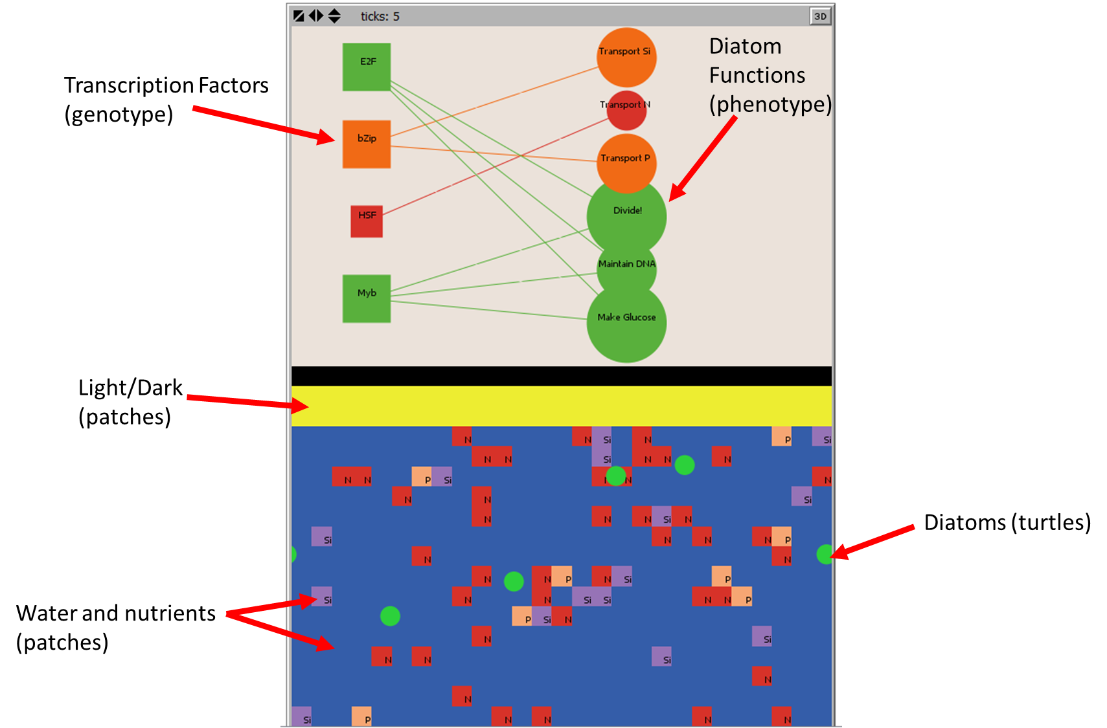

The left hand side allows the user to modify the conditions of the water, including nutrient levels (nitrogen, phosphorous, silicon, no units, arbitrary numbers), carbon dioxide concentration above the water (400 or 800 ppm), turn on/off the light, and add mixing (not implemented currently).

When the setup button is pressed, the lower patches are populated with nitrogen, silicon, and phosphorous according to the values of the sliders. Those nutrients can also be added in the amount indicated on the sliders at any point by hitting the “Add Nitrogen”, “Add Phosphorous”, or “Add Silicon” buttons.

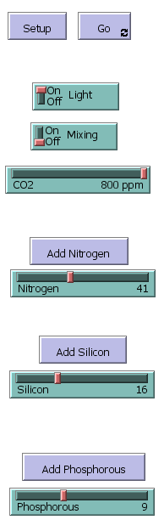

The right hand side shows graphs of the various nutrients and the diatom population, as well as the pH and CO2 levels (which are static and directly correlated).

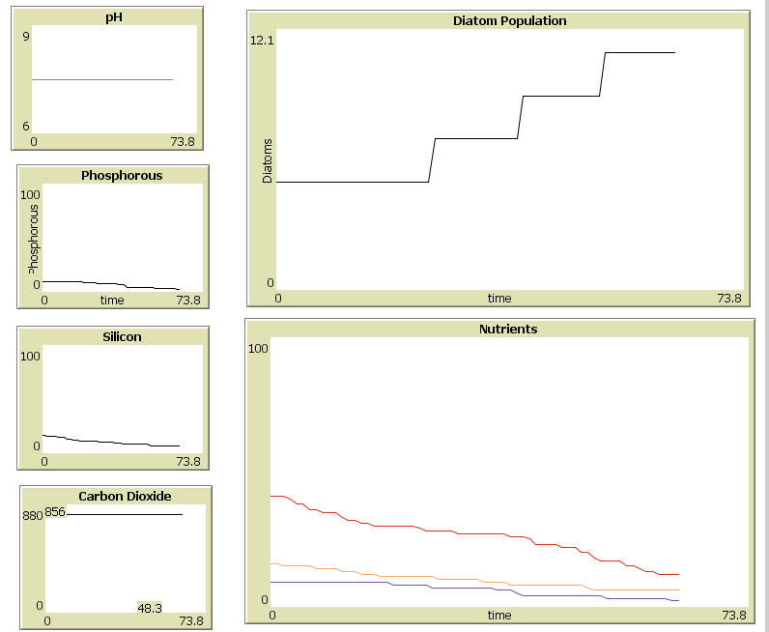

Here are the assumptions made to produce this model:

# #1 Diatoms:

* + Move randomly on the blue patches
  + Feed on nutrients and track how many nutrients they have collected
  + If there is light and they have 1 each of P, Si, and N they can reproduce, spawning “children” at a rate which depends on carbon dioxide. Reproducing costs 1 each of P, Si, and N Diatoms have a “health” variable, but it is not currently used.

#2 Transcription Factors: The activity of key transcription factors was assessed based off of Figure 4 in the paper (shown below) and led to the associations shown in the network model at the top of the next page.

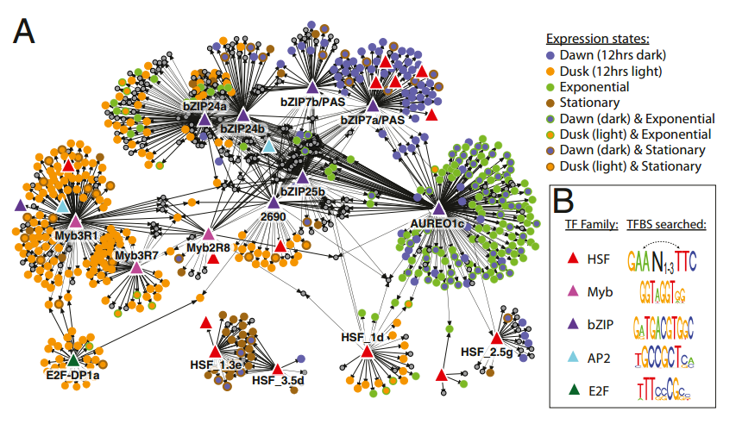

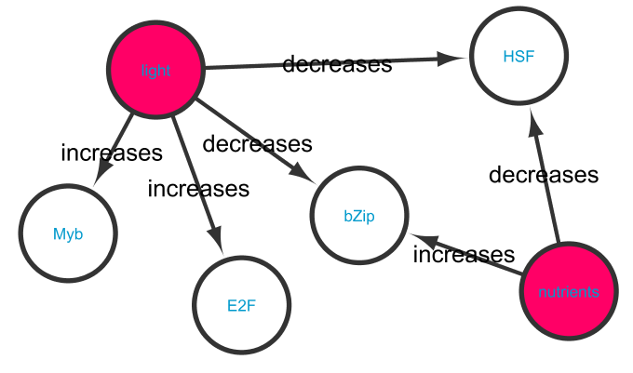

Rationalizations:

**A** 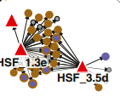

Since the genes associated with the stationary expression are regulated by HSF, we can assume that HSF is negative correlated with nutrients… hence in low nutrient situations, HSF is up-regulated.

**B** 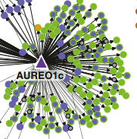

bZip is a regulator for genes associated with the exponential growth mode. Hence we can assume that bZIP is positively correlated with nutrients… at high nutrients situations, bZIP is up-regulated.

**C**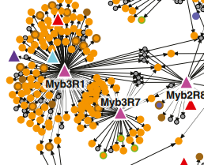 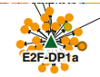

Myb and E2F are both regulators for genes associated with dusk. I take dusk to indicated positive light, since these regulators have been on all day. Hence Myb and E2F are positively correlated with light.

**D** 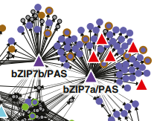

Both HSF and bZip are regulators for genes associated with dawn. This means that they are down-regulated by light.

# #3 Cellular Functions:

Specific cellular functions were assessed based on Figure 2 in the paper (shown below) and led to the associations shown in the network model after.

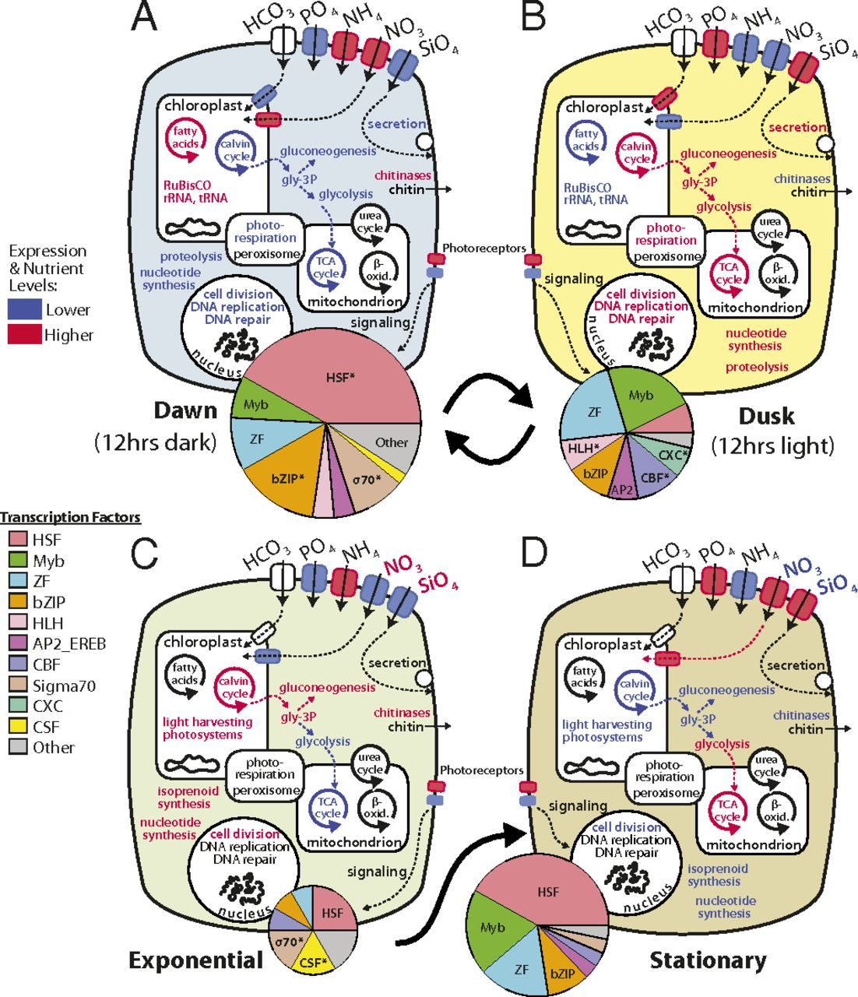

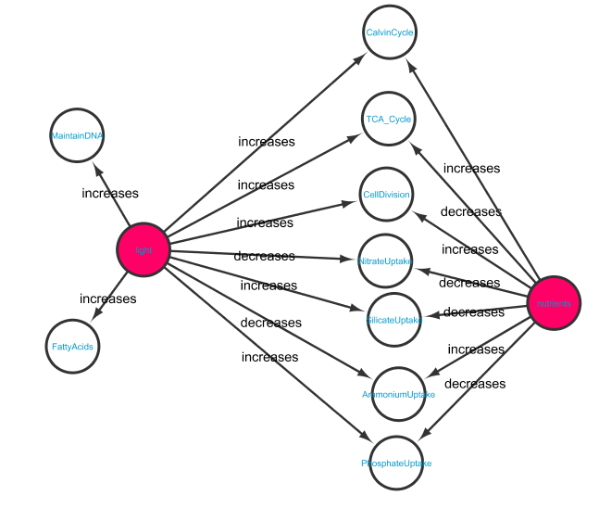

Rationalization: Effects of light were assessed by looking at parts A and B of figure 2. Blue colors in the figure are decreased, while red colors are increased.

|  |  |  |
| --- | --- | --- |
|  | Blue (down-regulated) | Red (up-regulated) |
| Dawn (-light) | Calvin Cycle  Phosphate uptake  Silicate uptake  Cell Division  TCA Cycle  Maintaining DNA | Nitrate uptake  Ammonium uptake  Fatty acids |
| Dusk (+ light) | Nitrate uptake  Ammonium uptake  Fatty acids | Calvin Cycle  Phosphate uptake  Silicate uptake  Cell Division  TCA Cycle  Maintaining DNA |
| Exponential (+nutrients) | TCA Cycle  Nitrate uptake  Phosphate uptake  Silicate uptake | Ammonium Uptake  Cell Division  Calvin Cycle |
| Stationary (-nutrients) | Ammonium Uptake  Cell Division  Calvin Cycle | TCA Cycle  Nitrate uptake  Phosphate uptake  Silicate uptake |

# Depictions of Effects of Light and Nutrients on Transcription Factors and Cellular Functions:

* Transcription factors and cellular functions which are being ONLY up-regulated are depicted as green. The size of turtle is correlated with how much it is being up-regulated. For example, glucose is up-regulated by both nutrients and by light, hence it is a large green circle when both of these stimuli are present). Maintaining DNA is only affected by light, and hence it is a smaller green circle whenever light is present.
* Transcription factors and cellular functions which are being both up-regulated and down-regulated are depicted as orange.
* Transcription factors and cellular functions which are being ONLY down-regulated are depicted as red.
* Production of Glucose indicates Calvin Cycle.
* Uptake of Nitrogen indicated only NITRATE, and not AMMONIUM. Ammonium uptake increases with nutrients, while nitrate uptake decreases.
* There are lines going between transcription factors and cellular functions, but these are not causal. They just look nice ☺

# Questions and Possible Modifications:

Modifications:

* Add a death rate for the diatoms. Diatoms lacking nutrients in particular would be at risk.
* More clearly depict the effects of ocean acidification. The followup paper “Diatom acclimation to elevated CO2 via cAMP signaling and coordinated gene expression” more clearly discussed the effects of higher CO2 concentration specific mechanisms in the diatoms.
* Show metabolism of glucose based on TCA cycle.
* Incorporates some actual genes into the top area so that we can see specifically which ones are activated and which are suppressed.